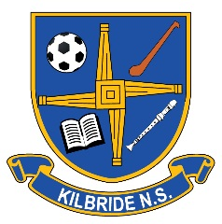
Ní neart go cur le chéile
KILBRIDE NATIONAL SCHOOL
Charity Regulator Number 20131265
Kilbride, Trim, Co. Meath. Roll No: 17513A
Phone: 046 943194 Email: info@kilbridenstrim.ie www.facebook.com/kilbridens/ www.kilbridenstrim.ie

ANNUAL ADMISSION NOTICE
in respect of admissions to the 2022/2023 school year
Special Class for Children with Autism Spectrum Disorder

Admission Policy and Application Form
A copy of the school’s Admission Policy and the Application Form for Admission for the 2022/2023 is available as follows: –
To download at: www.kilbridenstrim.ie
On request: By emailing info@kilbridenstrim.ie or writing to: Kilbride National School, Kilbride, Trim, Co. Meath.

PART 1 - Admissions to the 2022/2023 school year

Application and Decision Dates for admission to 2022/2023
The following are the dates applicable for admission to the Special Class for Children with Autism Spectrum Disorder

The school will commence accepting applications for admission on | 31st March 2022
The school shall cease accepting applications for admission on | 14th April 2022
The date by which applicants will be notified of the decision on their application is | 28th April 2022
The period within which applicants must confirm acceptance of an offer of admission is; 15:00pm on the date which falls two calendar weeks after the date of offer. Failure to accept a place within the two-week time frame will result in the place being offered to the next applicant on the list. | Two Weeks

Note: the school will consider and issue decisions on late applications in accordance with the school’s admission policy.
Number of places being made available in 2022/2023
The number of places being made available in junior infants is | 6

As per Admissions Policy the BOM has deemed 6 as the number of spaces available in the Special Class for Children with Autism Spectrum Disorder. The BOM reserves the right to change this number as necessary.

